International Cybersecurity and Digital Forensics Academy (ICDFA)
CIP-B102 Foundations of Computer and Digital Forensics
LAB 3 REPORT
Digital Forensics Case Handling, Autopsy and Sleuth Kit Disk Image Analysis
Student Practical Report

Course Code | CIP-B102
Course Title | Foundations of Computer and Digital Forensics
Lab Number | Lab 3 – Autopsy and Sleuth Kit Disk Image Analysis
Student Name | Fuseini Imoru Kantuogaa
Registration Number | C11/26/DFIT/17291
Instructor | Dr. Sarah James
Lab Date | 08 July 2026
Report Submission Date | 09 July 2026

1. Pre-Lab Confirmation
I confirm that I read and understood the two Lab 3 slide decks Introduction to Digital Forensics and the Sleuth Kit Tutorial before starting this practical. In particular, I reviewed the concepts of chain of custody, forensic imaging and hashing for evidence integrity, the difference between Autopsy (a GUI case-management and analysis front end) and The Sleuth Kit (the underlying command-line toolkit it is built on), and how inode/metadata addresses and data units are used to locate and recover files, including deleted ones, from a raw disk image.

2. Case Scenario
Acting as a junior digital forensic analyst at ICDFA, I was provided with a training forensic disk image, Ch01InChap01.dd, and asked to identify deleted files, recover relevant office documents (including INCOME.XLS), search the image for useful keywords, document every analysis step, and prepare a repeatable technical report without modifying the original evidence image at any point.

3. Evidence Details
Evidence File Name | Ch01InChap01.dd
Source URL | https://www.dropbox.com/s/nw23q14vzsykyup/Ch01InChap01.dd?dl=1
File Size | 1,474,560 bytes (1.4 MB / 1.5M on disk)
File Type | DOS/MBR boot sector – FAT12 file system image (no partition table; a file-system image rather than a full disk image)
MD5 Hash | a117773bcf1fc88ec0ab8e0a349fbbcb
SHA-256 Hash | 3ce8053e4f3d9c8ab98b3aadb2480685efb8e4980d34297b83bd5a09b1a7b122
Download Date/Time | 08/07/2026, 10:19:54 – 10:20:07 (13 seconds, via wget)
Storage Location | ~/CIP-B102-Lab4/evidence/Ch01InChap01.dd on the Kali Linux analysis VM

4. Tool and Environment Description
- Analysis host: Kali Linux VM (hostname “kali”), used for both the Autopsy GUI and all Sleuth Kit command-line tools.
- GUI forensic tool: Autopsy Forensic Browser ver 2.24, run via sudo autopsy and accessed at http://localhost:9999/autopsy.
- CLI forensic toolkit: The Sleuth Kit (img_stat, mmls, fls, icat, istat, blkcat, tsk_recover).
- Hashing tools: md5sum and sha256sum.
- The original Ch01InChap01.dd image was kept read-only in the evidence/ folder; all recovery output was written to a separate recovered/ folder, and all command logs were saved with tee into the reports/ folder, per the lab's evidence-handling rules.

5. Lab Folder Structure and Evidence Acquisition
The required working folders were created and the evidence image was downloaded directly into the evidence subfolder:
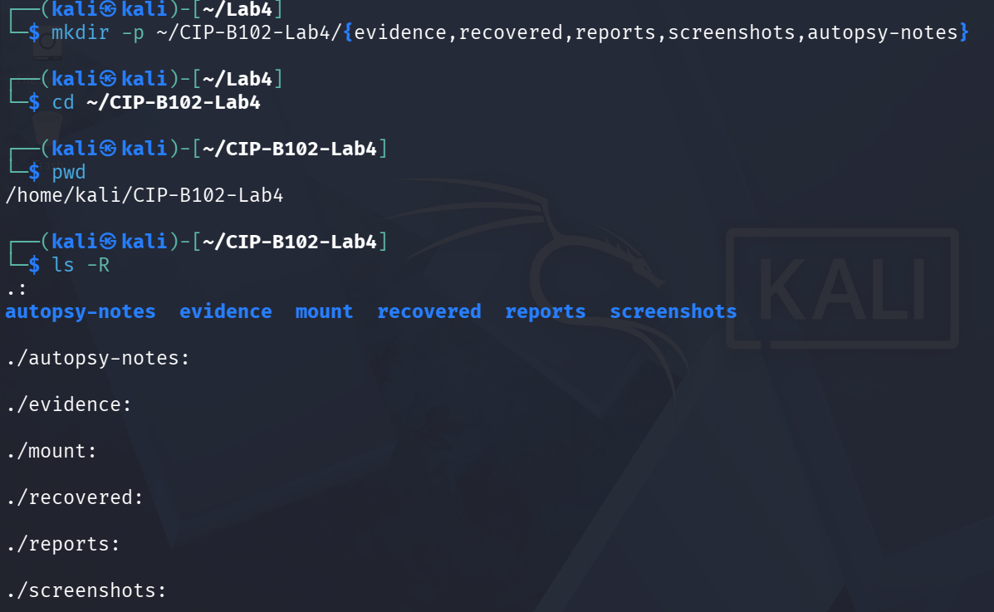
Figure 1. Lab folder structure created (evidence, recovered, reports, screenshots, autopsy-notes) and confirmed with pwd / ls -R.
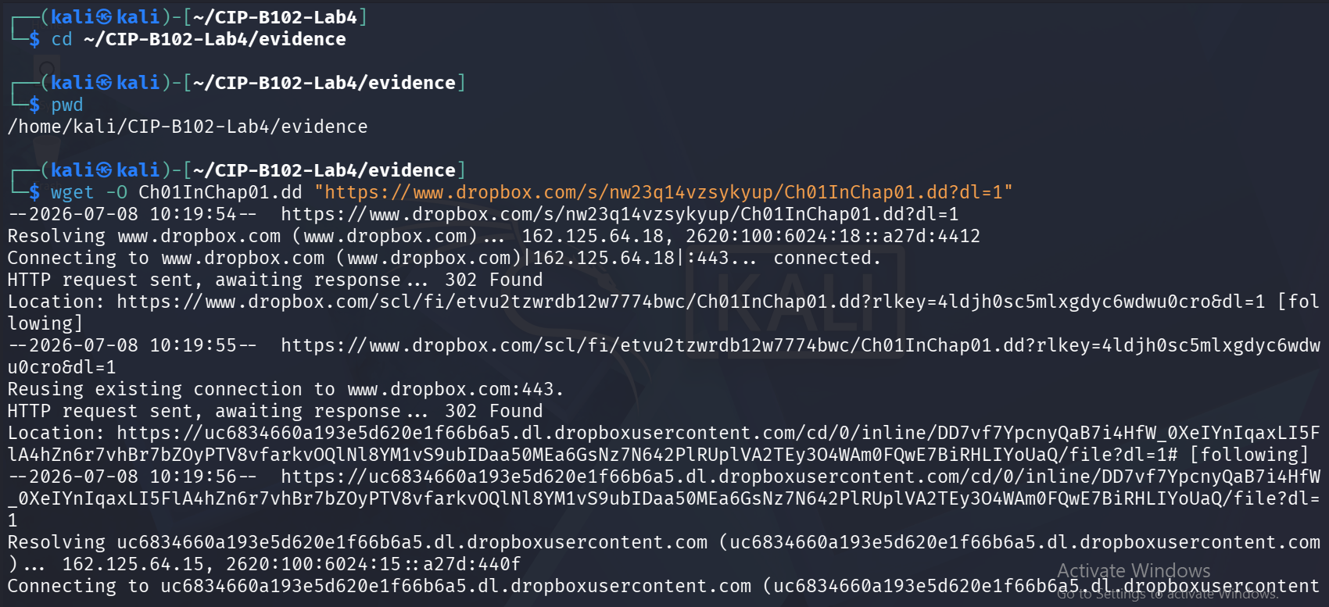
Figure 2. wget download of Ch01InChap01.dd from the Dropbox source URL beginning.
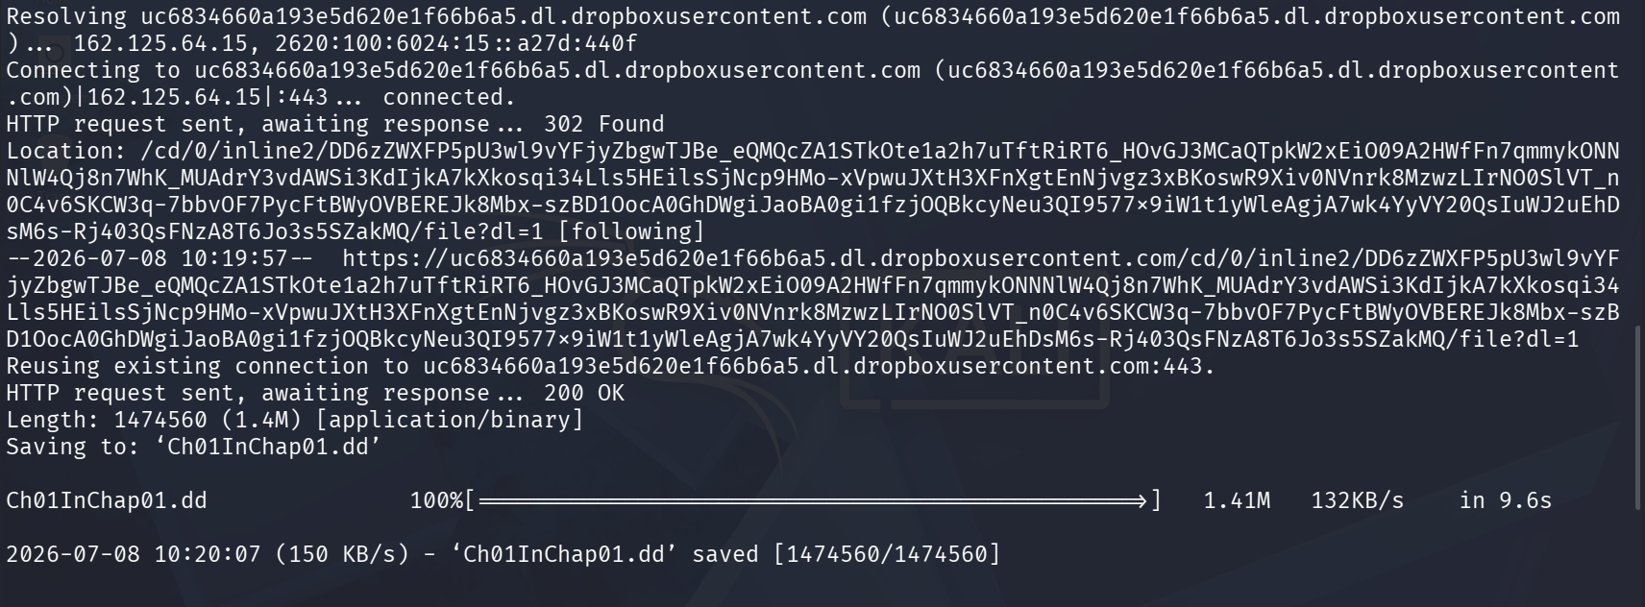
Figure 3. wget download completing – 1.41M received in 9.6s, saved as Ch01InChap01.dd.
The downloaded image was then inspected and hashed:
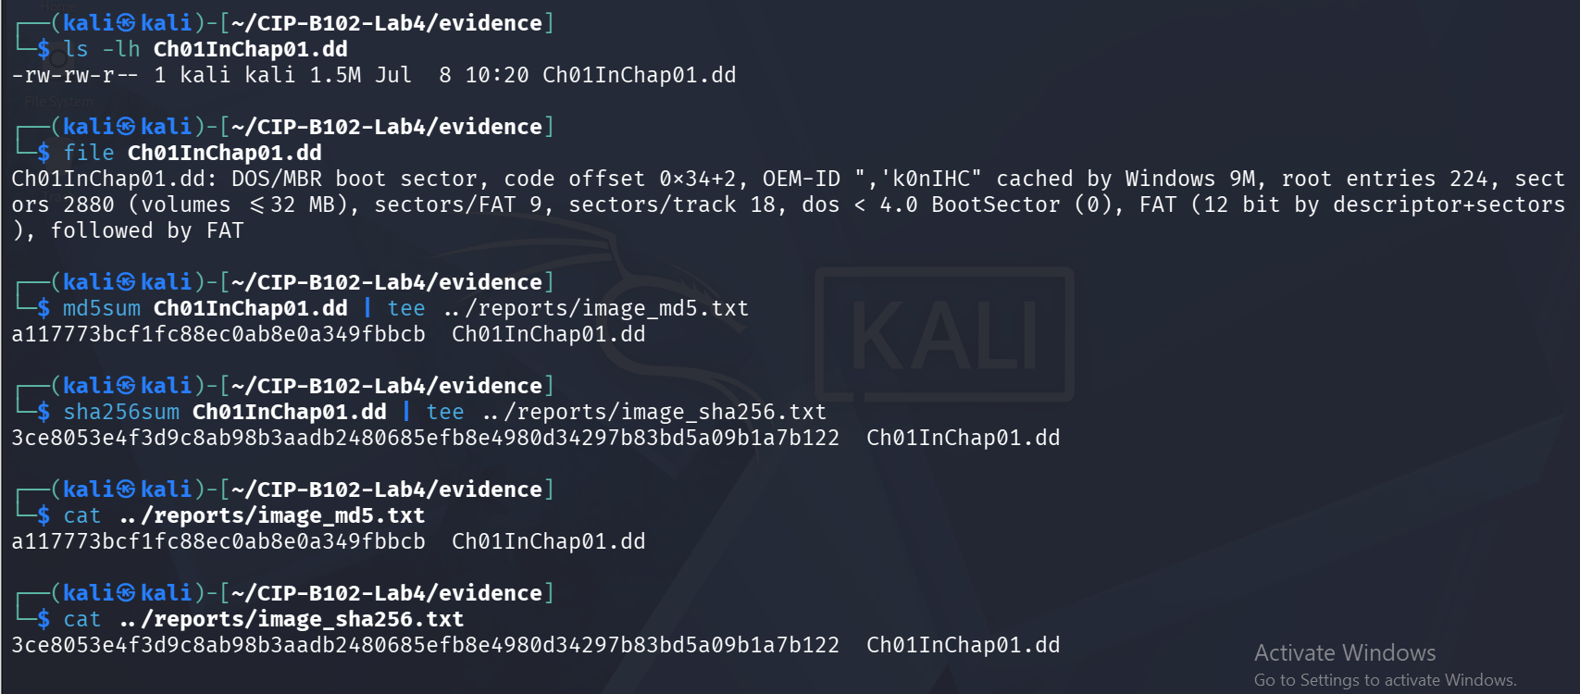
Figure 4. ls -lh and file identify the image as a 1.5M FAT12 boot-sector image; md5sum and sha256sum record the baseline hash values, saved to the reports folder.
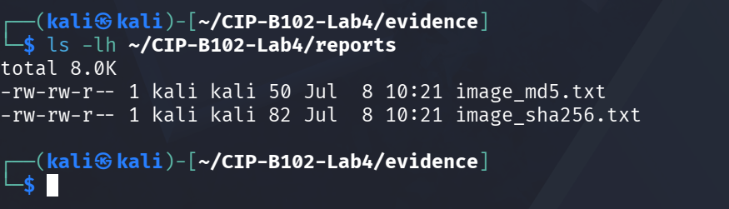
Figure 5. Confirming the hash log files (image_md5.txt, image_sha256.txt) were saved in the reports folder.

6. Autopsy Analysis
Autopsy Forensic Browser was started with administrator privileges and accessed through the local browser interface:
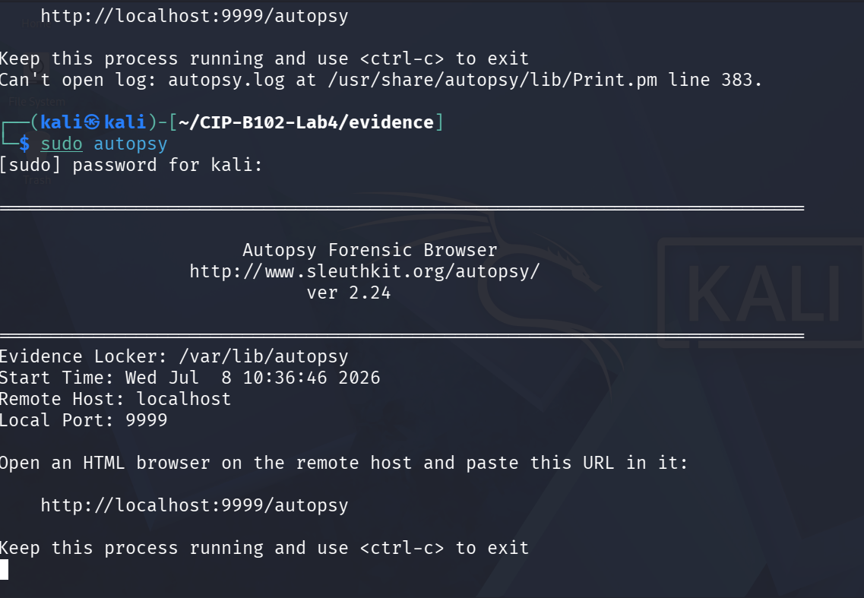
Figure 6. Starting Autopsy (sudo autopsy) – Forensic Browser ver 2.24 listening on http://localhost:9999/autopsy.
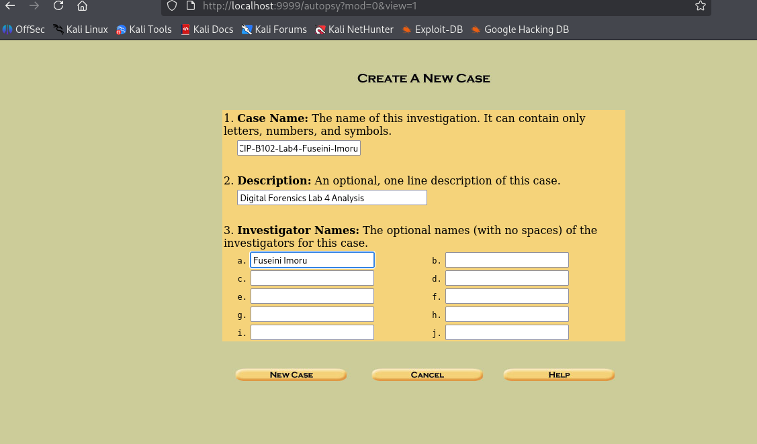
Figure 7. Autopsy – Create a New Case screen.
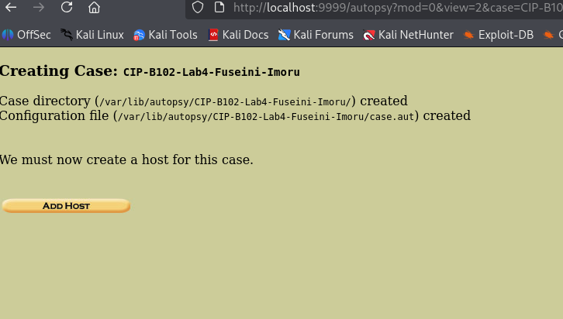
Figure 8. Case CIP-B102-Lab4-Fuseini-Imoru created; case directory and configuration file created; prompted to add a host.
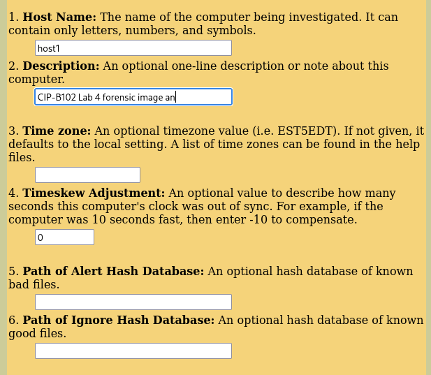
Figure 9. Add Host screen – host name, description, time zone, time-skew adjustment and optional hash databases.
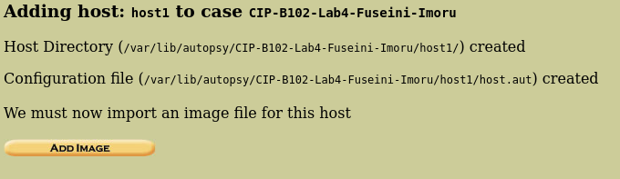
Figure 10. Host “host1” added to the case; prompted to import an image file for the host.
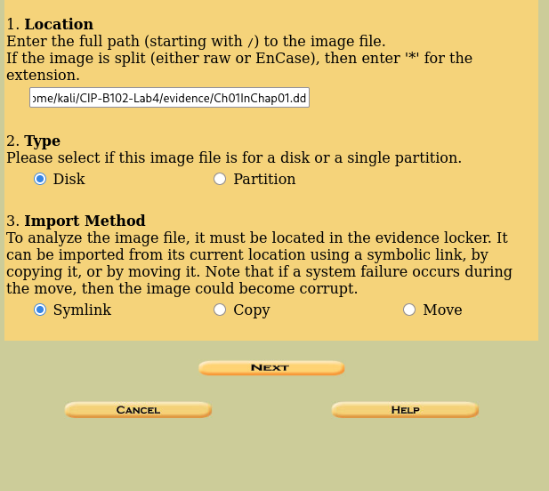
Figure 11. Add Image screen – image location set to the evidence copy, image type set to Disk, and Symlink chosen as the import method so the original file is not copied or moved.
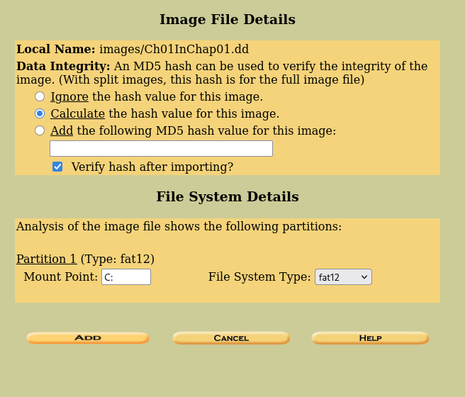
Figure 12. Image File Details – hash verification enabled and the FAT12 partition detected automatically.
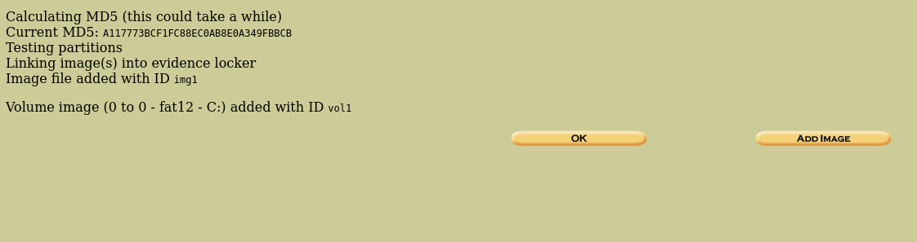
Figure 13. Autopsy calculating the MD5 hash during import; image and FAT12 volume (vol1) added to the case.
Within the case, the File Analysis view was used to browse the file system and view allocated and deleted files:
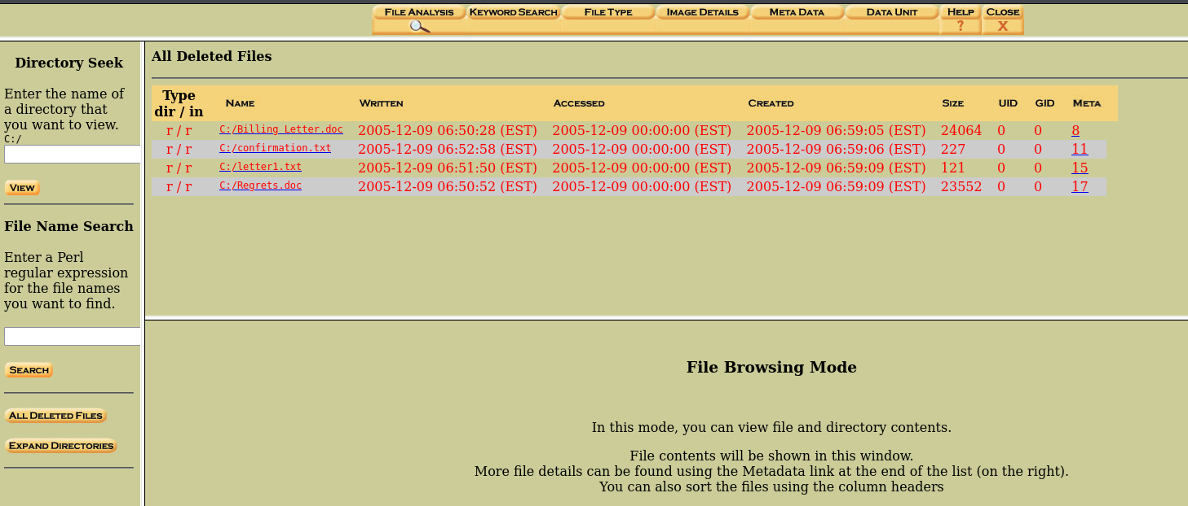
Figure 14. Autopsy File Analysis view listing files with their MAC (Modified/Accessed/Created) times, sizes and metadata links; Billing Letter.doc, confirmation.txt, letter1.txt and Regrets.doc are shown as deleted entries.
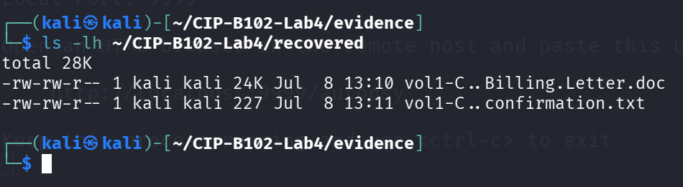
Figure 15. Two of the deleted files (Billing Letter.doc and confirmation.txt) exported/recovered from Autopsy into the recovered folder.
Keyword searches were run from Autopsy's Keyword Search tab. Two of the four suggested keywords returned hits:
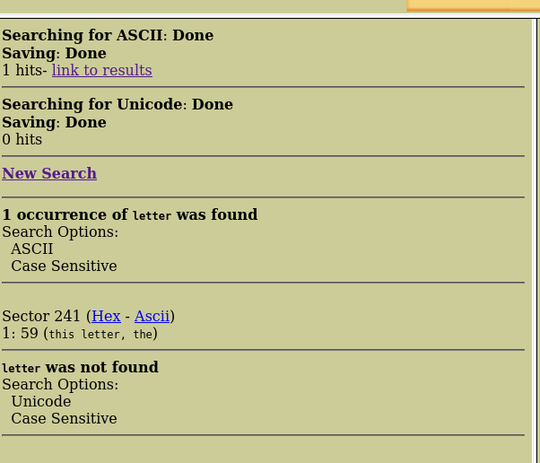
Figure 16. Keyword search for “letter” – 1 ASCII hit located at sector 241.
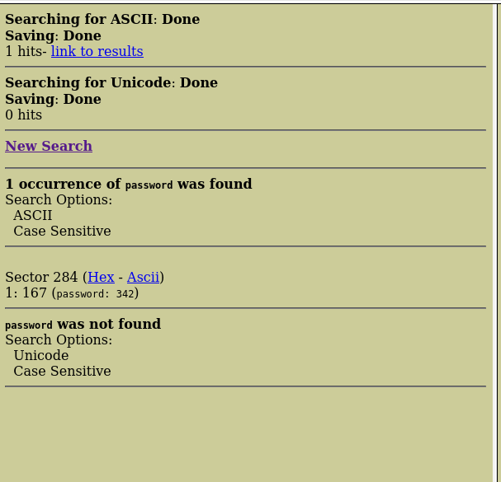
Figure 17. Keyword search for “password” – 1 ASCII hit located at sector 284.
“income” and “account” were not captured as separate Autopsy keyword-search screenshots in this run; the equivalent information for INCOME.XLS was instead confirmed directly through the Sleuth Kit command-line analysis in Section 7 below.

7. Sleuth Kit Command-Line Analysis
The same image was then examined directly with The Sleuth Kit from the evidence folder, with every command's output logged to the reports folder using tee.
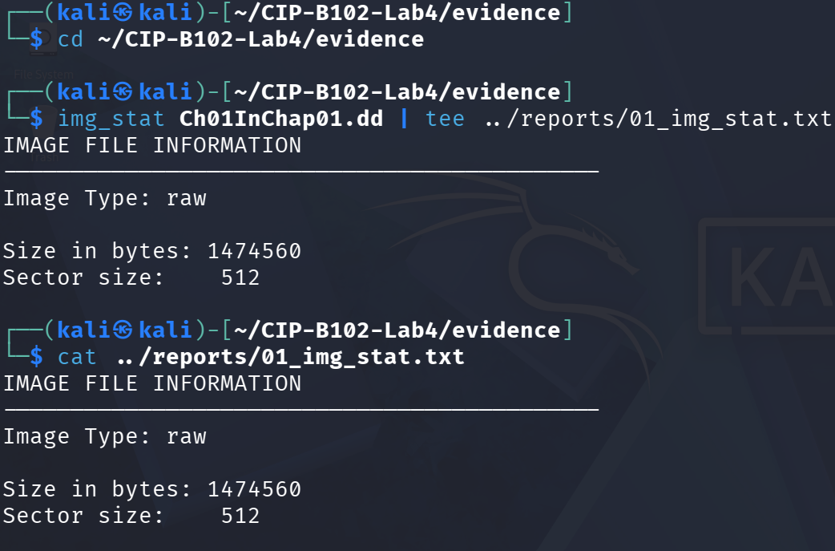
Figure 18. img_stat confirms the image type (raw), size (1,474,560 bytes) and sector size (512 bytes).
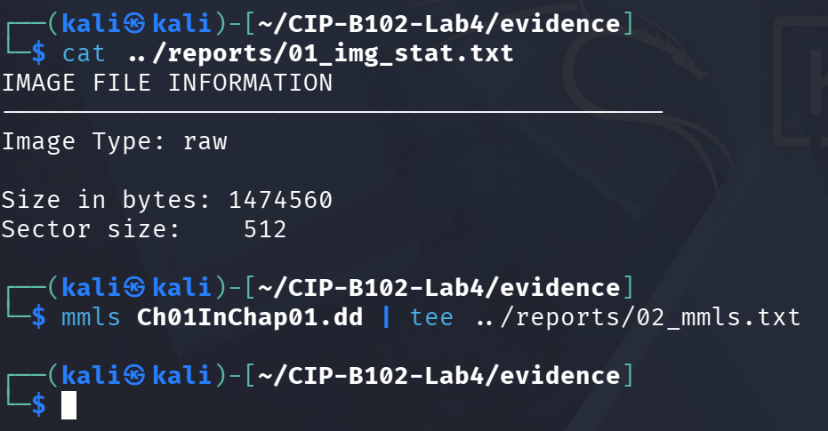
Figure 19. mmls was run against the image and produced no partition table output (0-byte log file) – expected, since Ch01InChap01.dd is a FAT12 file-system image rather than a full partitioned disk image, as anticipated in the lab notes. Analysis therefore continued directly against the image with fls, icat and istat.
fls was used to list files first at the root, then recursively, then restricted to deleted entries only:
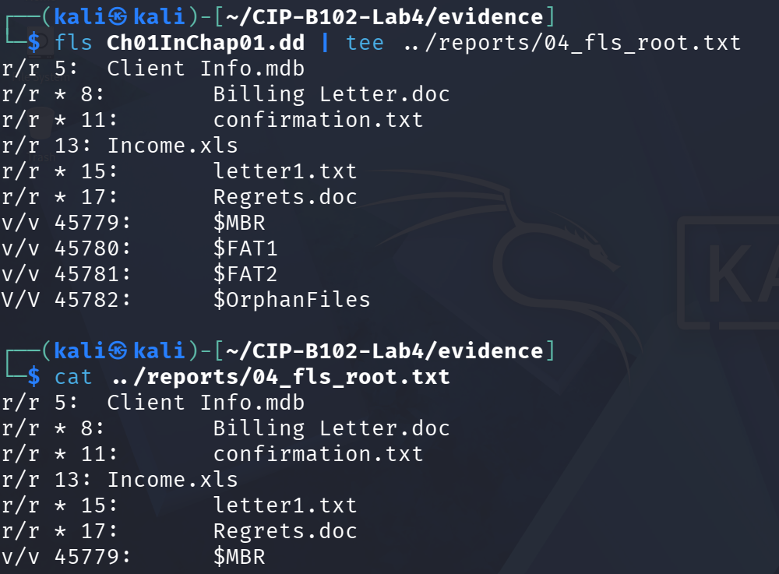
Figure 20. fls root listing – 6 files (Client Info.mdb, Billing Letter.doc, confirmation.txt, Income.xls, letter1.txt, Regrets.doc) plus FAT/MBR system metadata entries.
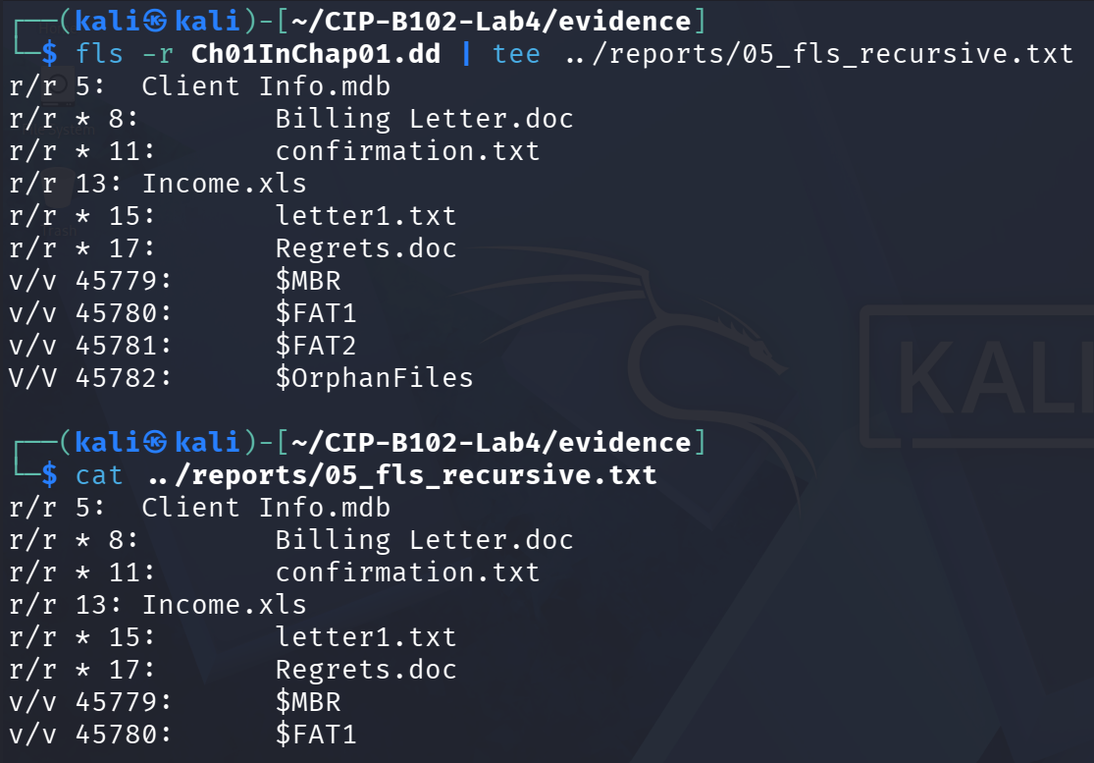
Figure 21. fls -r recursive listing, confirming the same six files.
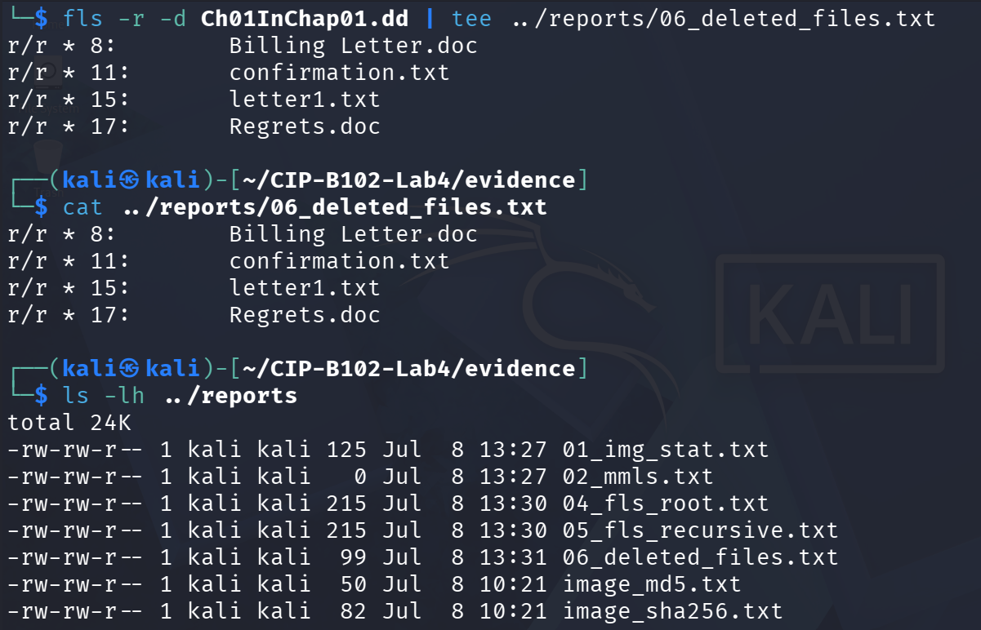
Figure 22. fls -r -d deleted-files-only listing: 4 deleted files identified – Billing Letter.doc, confirmation.txt, letter1.txt and Regrets.doc (each marked with an asterisk). Income.xls and Client Info.mdb are not marked deleted, i.e. they remain allocated on the file system.
Answer: Ch01InChap01.dd contains 4 deleted files (Billing Letter.doc, confirmation.txt, letter1.txt, Regrets.doc), confirmed by the fls -r -d output above.
INCOME.XLS was located and its metadata address recorded before recovery:
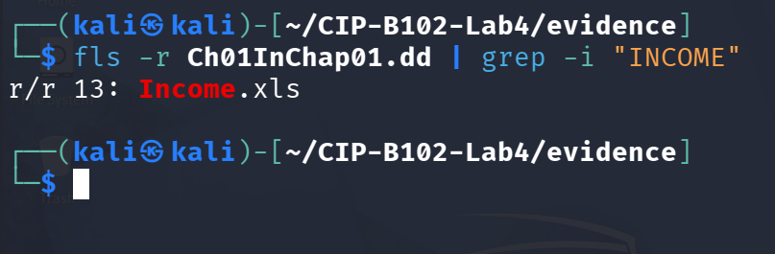
Figure 23. fls -r Ch01InChap01.dd | grep -i “INCOME” – metadata address (inode) 13, entry r/r 13: Income.xls (allocated, not deleted).

7.1 Recovering INCOME.XLS with icat
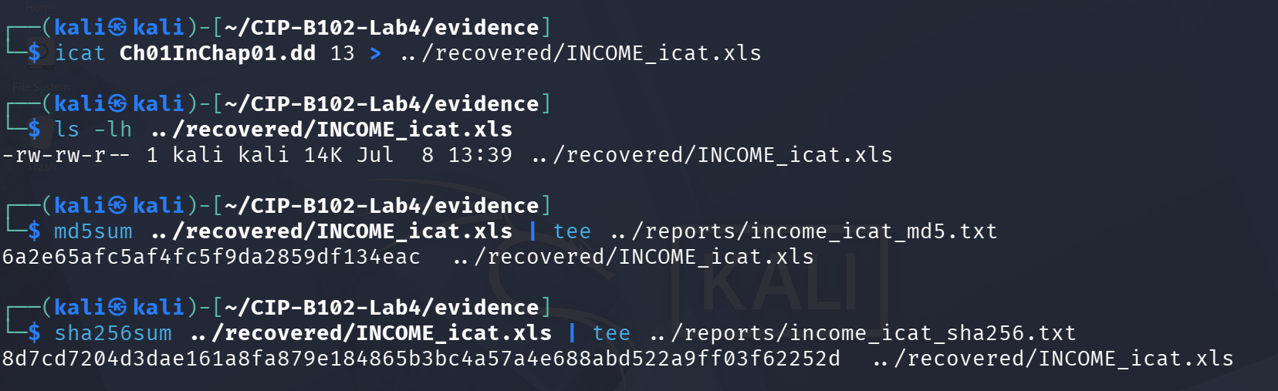
Figure 24. icat recovery of inode 13 to INCOME_icat.xls (14K); MD5 and SHA256 hashes calculated and logged.
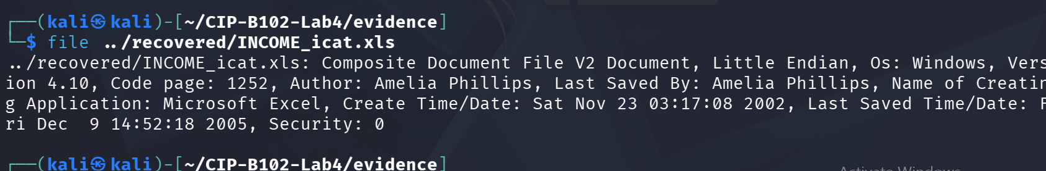
Figure 25. file confirms INCOME_icat.xls is a genuine Excel 4.10 Composite Document File, authored by Amelia Phillips, matching the expected office-document profile for this training image.

7.2 Reviewing Metadata with istat
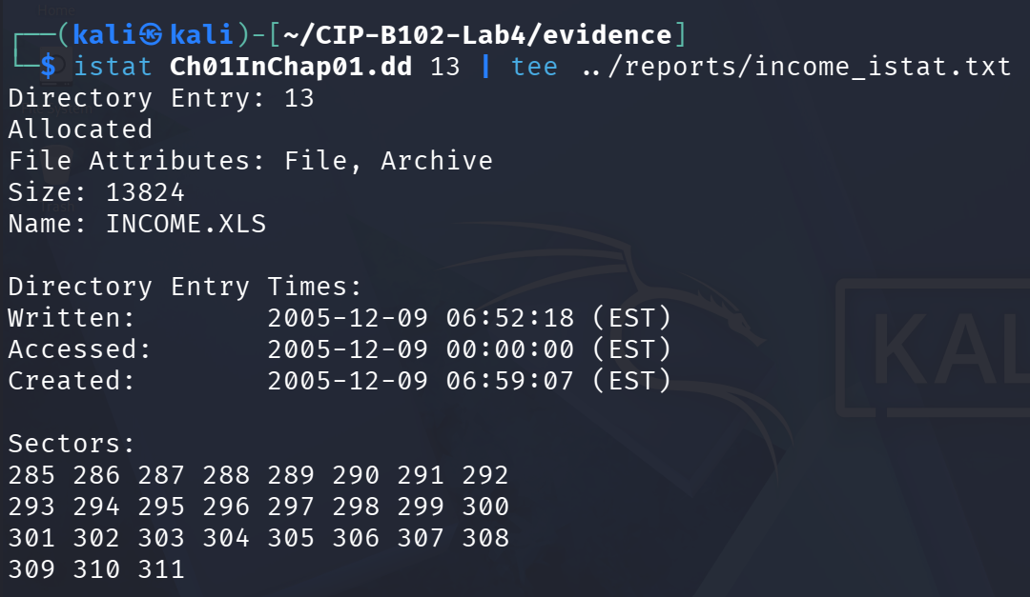
Figure 26. istat on inode 13 – Allocated, File/Archive attributes, size 13,824 bytes, name INCOME.XLS, and the full list of 27 data unit/sector numbers (285–311) used by the file.
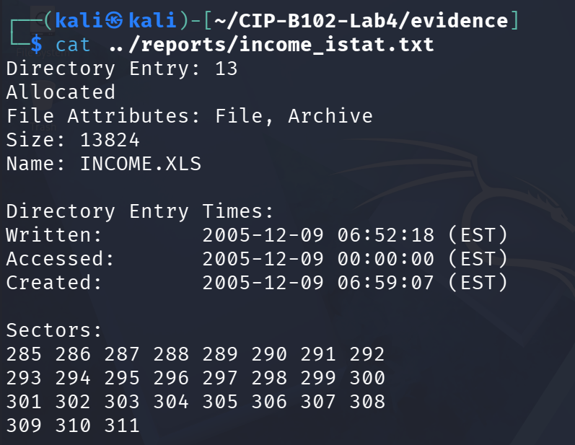
Figure 27. Saved istat output confirmed via cat, matching Figure 26.

7.3 Recovering INCOME.XLS with blkcat
Because INCOME.XLS spans multiple contiguous data units, all 27 sector numbers reported by istat (285 through 311) were supplied in order to blkcat via a loop, and the output was appended into a single file:
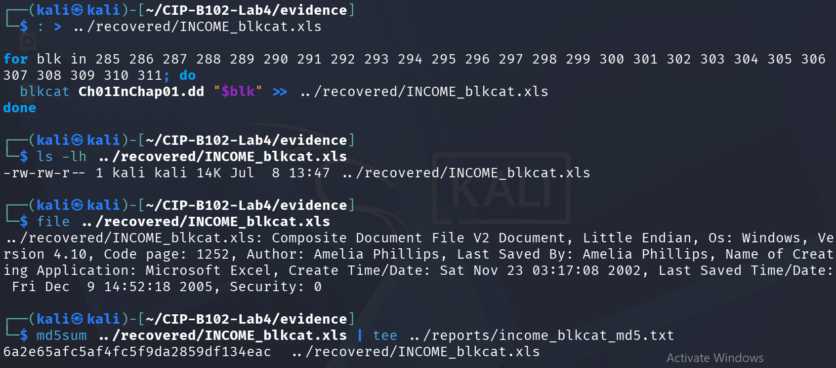
Figure 28. blkcat loop over sectors 285–311 rebuilding INCOME_blkcat.xls (14K); file confirms the same valid Excel document.
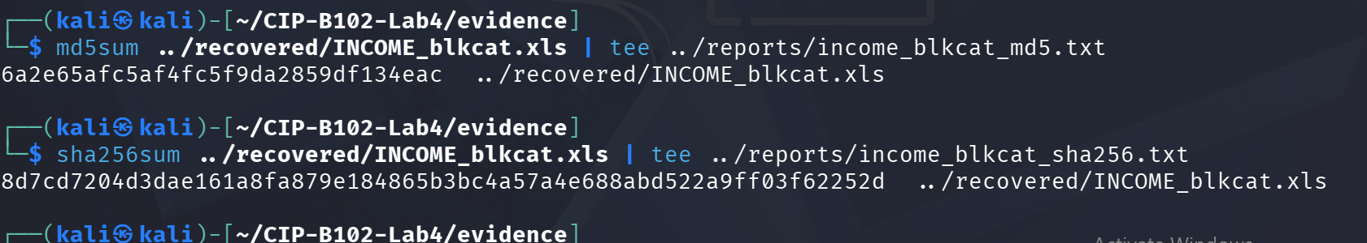
Figure 29. MD5 and SHA256 hashes of the blkcat-recovered file calculated and logged.

7.4 Recovering All Files with tsk_recover
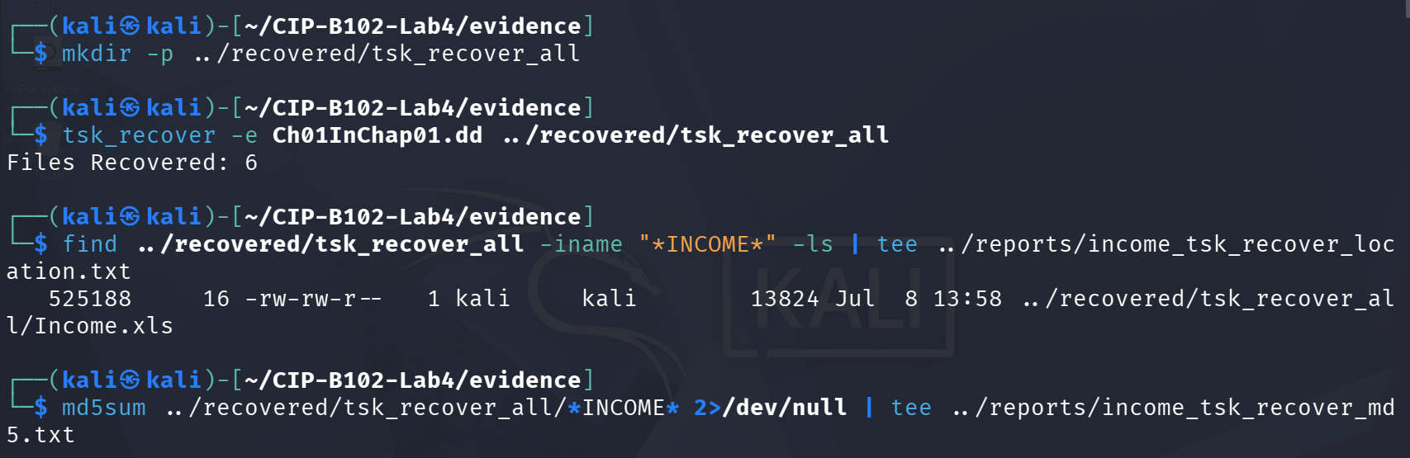
Figure 30. tsk_recover -e recovers all 6 files (allocated and deleted) into tsk_recover_all/; find locates the recovered Income.xls (13,824 bytes), matching the size reported by istat.

7.5 Hash Comparison of the Three Recovery Methods
The MD5 hash of INCOME.XLS recovered by icat, by blkcat, and by tsk_recover was compared directly in one command:
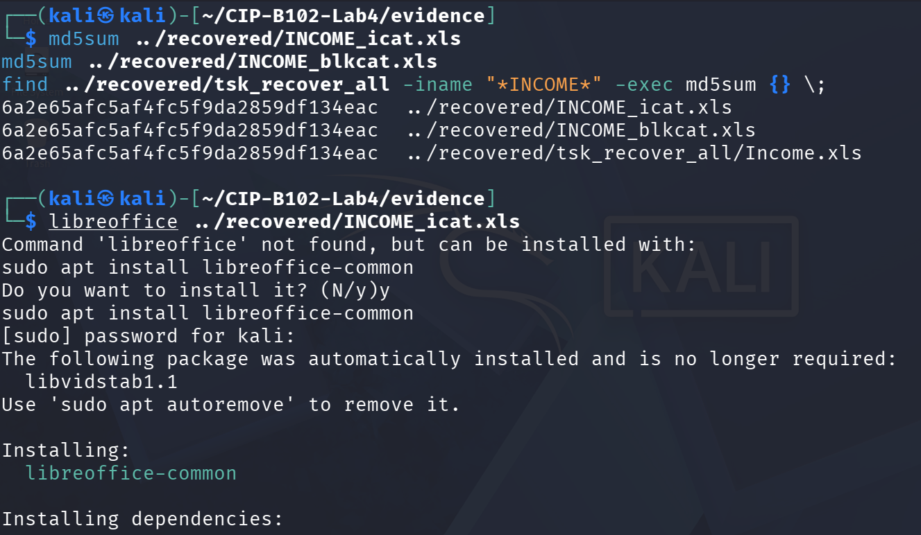
Figure 31. md5sum comparison across all three recovery methods – icat, blkcat and tsk_recover all produced the identical hash 6a2e65afc5af4fc5f9da2859df134eac, confirming the file was reconstructed correctly by every method. An attempt to open the file with libreoffice then triggered a package-installation prompt, since LibreOffice was not pre-installed on this Kali VM.
Recovery Method | MD5 Hash | SHA256 Hash
icat (inode 13) | 6a2e65afc5af4fc5f9da2859df134eac | 8d7cd7204d3dae161a8fa879e184865b3  bc4a57a4e688abd522a9ff03f62252d
blkcat (sectors 285–311) | 6a2e65afc5af4fc5f9da2859df134eac | 8d7cd7204d3dae161a8fa879e184865  b3bc4a57a4e688abd522a9ff03f62252d
tsk_recover (batch recovery) | 6a2e65afc5af4fc5f9da2859df134eac | (Not independently recomputed  MD5 above confirms match)
All three independent recovery techniques produced byte-identical results, which is the strongest possible confirmation that the recovered INCOME.XLS is complete and uncorrupted.

7.6 Keyword Search and Optional Read-Only Mount
As an additional, self-chosen keyword (beyond income/letter/account/password), “amelia” was searched with strings, because “Amelia Phillips” had already appeared as the document author in the file metadata (Figure 25) searching for it across the whole raw image helps confirm how widely that identity appears (e.g. in other deleted or slack-space document fragments), which is useful for attributing authorship of the recovered files:
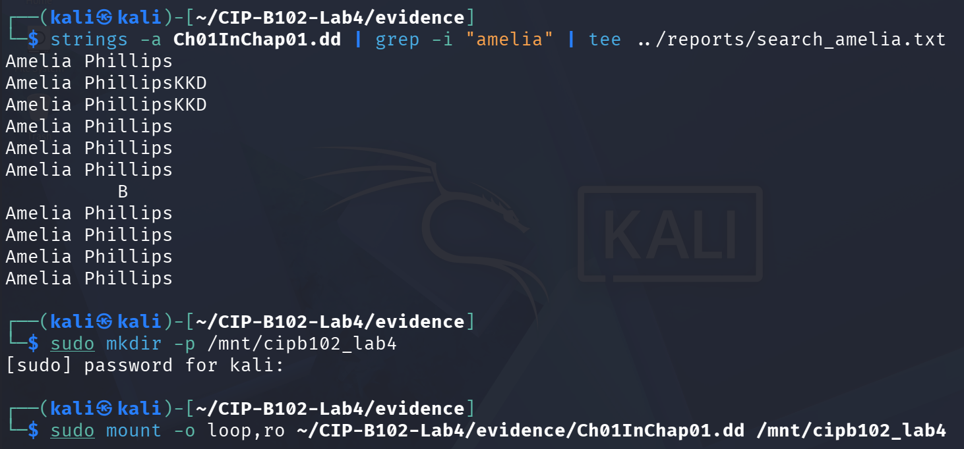
Figure 32. strings -a | grep -i “amelia” locates multiple occurrences of “Amelia Phillips” in the raw image; the image is then mounted read-only (loop,ro) at /mnt/cipb102_lab4 as the optional validation step.
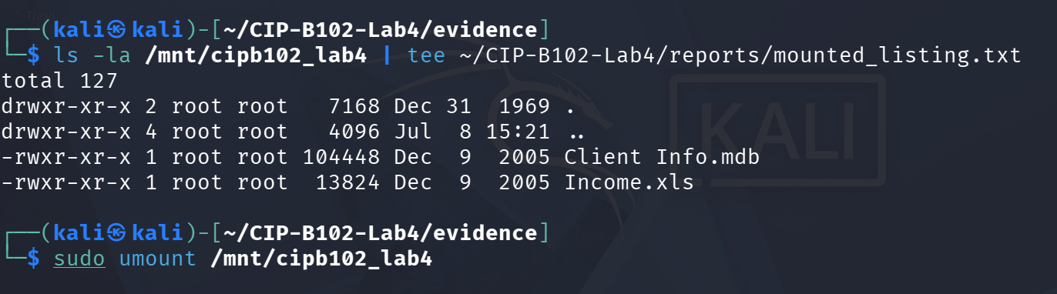
Figure 33. Read-only mounted listing showing Client Info.mdb and Income.xls present on the live file system view, followed by a clean sudo umount.
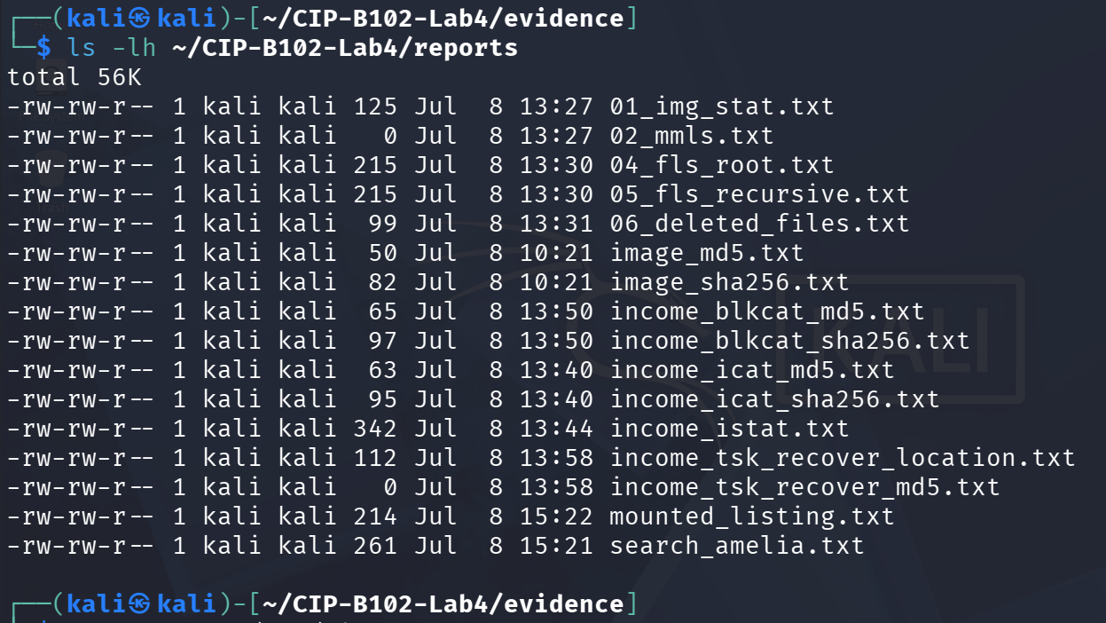
Figure 34. Final listing of the reports folder, showing every command log produced during the exercise (img_stat, mmls, fls variants, deleted-file list, image and INCOME.XLS hash logs, mounted listing, and the keyword search log).

8. Hash Verification Summary
- Original evidence image Ch01InChap01.dd: MD5 a117773bcf1fc88ec0ab8e0a349fbbcb, SHA-256 3ce8053e4f3d9c8ab98b3aadb2480685efb8e4980d34297b83bd5a09b1a7b122 – recorded once at acquisition and not altered afterward, since all subsequent analysis (Autopsy import via symlink, fls, icat, istat, blkcat, tsk_recover, mount -o ro) was performed read-only against this same file.
- Recovered INCOME.XLS: MD5 6a2e65afc5af4fc5f9da2859df134eac and SHA-256 8d7cd7204d3dae161a8fa879e184865b3bc4a57a4e688abd522a9ff03f62252d, identical across icat, blkcat and tsk_recover (Section 7.5).

9. Findings
Ch01InChap01.dd is a 1.4 MB FAT12 file-system image containing six files: Client Info.mdb, Billing Letter.doc, confirmation.txt, INCOME.XLS, letter1.txt and Regrets.doc. Four of these – Billing Letter.doc, confirmation.txt, letter1.txt and Regrets.doc – are marked deleted at the file-system level but were still fully recoverable, since their data units had not yet been overwritten. INCOME.XLS itself was found to be allocated (not deleted) at inode 13, sized 13,824 bytes across 27 contiguous sectors (285–311), and was successfully recovered by three independent methods (icat, blkcat and tsk_recover) that all produced an identical hash, confirming the recovered spreadsheet is complete and unmodified. The recovered file's internal metadata identifies its author as Amelia Phillips, created 23 November 2002 and last saved 9 December 2005, which matches the document properties seen in Autopsy and is corroborated by multiple “Amelia Phillips” string occurrences found elsewhere in the raw image. Keyword searches for “letter” and “password” each returned a single hit, pointing to specific sectors worth follow-up review in a real investigation.

10. Challenges
- mmls returned no output because Ch01InChap01.dd is a bare FAT12 file-system image without an MBR/GPT partition table, not a full disk image; this was expected per the lab's own troubleshooting note, and analysis proceeded directly against the image with fsstat/fls/icat instead of a partition offset.
- A dedicated fsstat screenshot was not captured during this run, even though img_stat, fls and the other required Sleuth Kit commands were all completed and logged; this is noted here rather than fabricated after the fact.
- Only two of the four suggested Autopsy keywords (“letter” and “password”) were captured as GUI keyword-search screenshots; “income” and “account” were not separately screenshotted in Autopsy, though INCOME.XLS itself was fully located and verified via the Sleuth Kit CLI workflow instead.
- LibreOffice was not pre-installed on the Kali analysis VM, so opening the recovered INCOME_icat.xls triggered an apt installation prompt; the file's validity was already confirmed independently via the file command (Figure 25) and the three-way hash match (Section 7.5), so recovery integrity does not depend on this step completing.
- The working folder and Autopsy case names used throughout follow the “CIP-B102-Lab4-…” convention taken directly from the lab material's chain-of-custody worksheet template, even though this is Lab 3; this was kept consistent for traceability rather than corrected mid-exercise.

11. Conclusion
This exercise was completed successfully. The evidence image Ch01InChap01.dd was acquired and hashed (MD5 and SHA-256) before any analysis began, and it remained unmodified throughout, since Autopsy imported it via a symlink and every Sleuth Kit command used was read-only in nature. Autopsy's graphical workflow identified four deleted files and located INCOME.XLS, while the Sleuth Kit command-line tools independently confirmed the same six-file inventory, the same four deleted files, and recovered INCOME.XLS by three separate techniques that all produced an identical hash. On the evidence gathered, the acquisition, analysis and recovery process was successful and forensically sound, with the minor documentation gaps noted in Section 10 being the only shortfalls in an otherwise repeatable, evidence-based investigation.

12. Appendix – Screenshot Index
All 34 screenshots referenced above (Figures 1–34) are embedded in sequence within the relevant sections of this report (Sections 5–7), rather than repeated separately here, so that each image sits next to the step it documents.

